**MONTHLY MEETING**

**March 1st 2023 *The Nuclear Deterrent and my part in your Survival***

A light-hearted journey through a young man’s work on Nuclear Submarines

**The Speaker**: Jerry came from a humble background and undertook a long apprenticeship in HM Naval Dockyard Rosyth. After qualifying as a technician, he carried out testing and calibration on Britain’s first two nuclear submarines. He spent some years in the UK defence industry holding directorships in BAe Systems, GEC, Marconi and Thorn-EMI Simtec. He is credited with solving problems that prevented manufacture of the army nerve agent detector, NAIAD, and the crippling corrosion affecting the build of new navy frigates. He went on to gain a Master of Science degree in management and technology and directed the UK’s largest professional photographic processing company.

He joined Pearson / Edexcel in 2000 and, as managing director, transformed the UK exam system. His authorising signature appears on literally millions of A levels, GCSEs and SATS tests. His book on the exam system caused some consternation on the exam regulators, and he was regularly featured in the national press and TV news.

*Linda Rothwell*

*Speaker Finder*

**VOLUNTEERS**

**Setting Up:** Rob Leam, Ernie Thornhill

**Refreshments:** Linda Lambert, Pat Collins, Janice Matthews, Georgia Hanson.

**Signing In:** Janet Lander, Sue Wheatley.

**Meet and Greet:** Barbara Moir, Pauline Daws.

*Doris Fellows*

*Volunteer Coordinator*

**NB. Some of you may have noticed that the temperature in the hall has been quite cool. The committee have investigated the reasons for this and it should be much warmer from now on.**

**NOTIFICATION OF EASTWOOD & DISTRICT U3A AGM**

The 9th Annual General Meeting of Eastwood & District U3A will be held on the 7th June 2023. Please consider whether you are able to put your name forward to be on the committee. Descriptions of all committee roles can be found on the website

<http://eastwoodu3a.org/committee/descriptions-of-committee-roles/>

If you want more information, please talk to any member of the committee.

**MEMBERSHIP SUBSCRIPTION**

Membership subscriptions are due before the 1st April 2023. Renewal forms are available on the website

[www.eastwoodu3a.org/forms](http://www.eastwoodu3a.org/forms)

**Whichever method you use to pay your subscription you MUST fill in a renewal form.**

If there are no changes to your details, fill in your name, membership number and date and sign the top section of the form. You must then complete the Privacy Statement to confirm your consent to the storage and use of your data.

The current subscription is £20 for the year, £17 for Associate Members.

**WAYS TO PAY**

If possible please pay your subscription by Bank transfer - a one off− bank payment. You must also complete a renewal form and email the treasurer to confirm payment.

Name of payee: Eastwood & District u3a

Sort code: 60-07-28

Account no: 456 35 714

Reference: Your name & membership no (this is essential for the treasurer to pick out who has paid)

Amount: £20

**You can pay by Bank transfer through your local post office if you don’t bank online.**

If you want to pay by cash or cheque please contact Barry Doran [**membership@eastwoodu3a.org**](membership@eastwoodu3a.org)

tel: 07565 928 992

**JOINT GIFT AID**

If you have signed a gift aid form for yourself and others in your household, the person who completed the gift aid form must pay the full joint amount and sign the renewal form.

**RESERVED SEATS AT THE MONTHLY MEETING**

At the monthly meetings, there will be reserved signs on some of the front seats, so that it will be easier for any who are especially hard of hearing, or have eyesight issues, to enjoy the speaker. Please feel free to sit on one of these seats if it would be of benefit to you.

*Janet Lander*

Steve McQueen won a Superman lookalike contest in 1964.

Yes, he was in the greatest cape!!

Membership Secretary [**membership@eastwoodu3a.org**](mailto:membership@eastwoodu3a.org) Tel 07565 928 992

Executive Committee Members: [**eastwoodu3a@gmail.com**](mailto:eastwoodu3a@gmail.com)

Website: [**www.eastwoodu3a.org**](http://www.eastwoodu3a.org/)

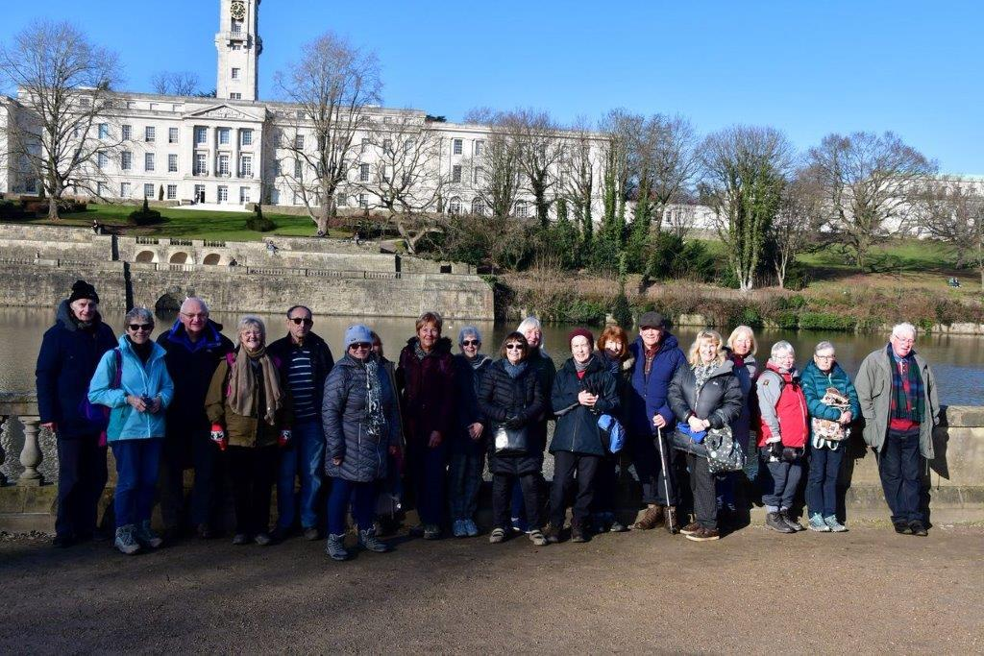

**WALKS, 5 MILES**

Our February Walk: Nottingham Canal/Highfield Park.

**SHOWCASE**

Our Showcase on 1st February was a really successful and fun event. Attendance was extremely good. This was in the main due to members putting up posters in local venues as well as a few notices on social media groups. I hope we can all agree it was worth our joint efforts to pull everything together.

There must be a mention here of the varied and interesting displays groups used. It was a great idea for Canasta and Bridge to set up demonstration games and the photography group’s eye catching display was lovely. A huge thank you must go out to all the group contacts for making the Showcase displays so varied.

As a result of the event many visitors joined the u3a and others are intending to visit groups first before making a final decision.

I observed people talking positively about what we offered, and due to interest expressed on the day several groups will begin shortly, amongst them  board games and day/social trips. The group contacts for these new groups will be in touch with interested people soon.

The Committee would like to express thanks to all our volunteers who helped set up the room and provide refreshments throughout. They were fantastic ! Thanks also go to anyone who helped their group by sharing their experiences and giving information with enthusIasm.

*Marianne Sparrow*

Walkers with the Portland Building in the background

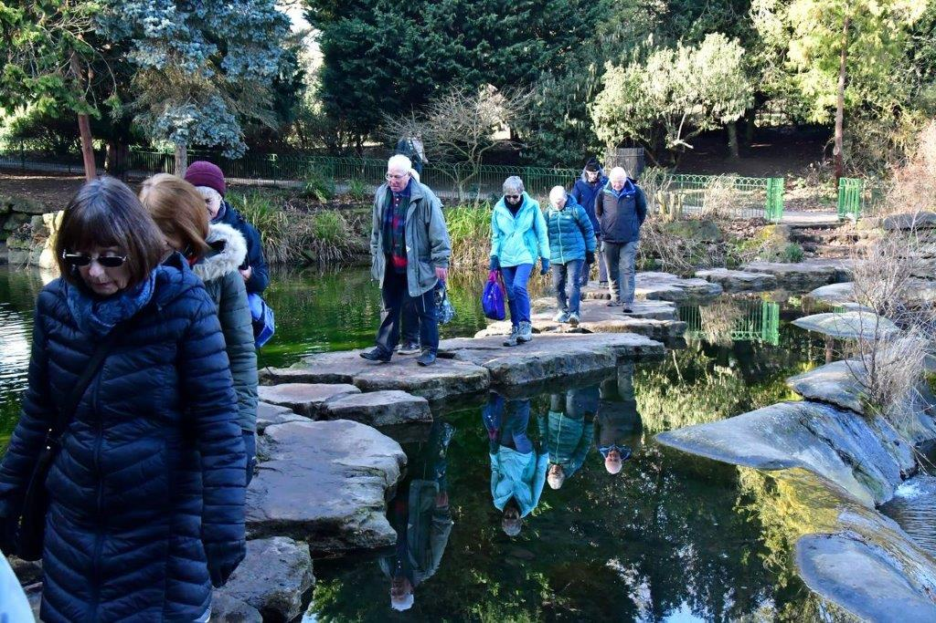

|  |  |  |
| --- | --- | --- |
| **GROUP COORDINATORS** | | |
| Anne’s Groups | Madeleine’s Groups | Marianne’s Groups |
| 1.All things environment 2.Board Games 3.Bridge 4.Coffee Mates 5.Creative Crafts 6.History of England 7.Pub Pals 8.National Trust 9.Radio Waves 10.Strollers 11.General Gardening (out of season) 12.War Babies and Boomers | 1.Art Appreciation  2.Bowls (no longer meeting)  3.Church History  4.Coffee and Co  5.Creative Writing  6.Family History  7.French Conversation  8.Local History (no longer meeting)  9.Poetry (no longer meeting)  10.Psychology 11.Rediscovering Nottingham (maybe starting in the Spring/Summer) 12.Spanish | 1. Bird watching 2. Book group/s 3. Canasta 4. Gogglebox 5. Petanque 6. Photography 7. Theatre 8. 5ml Walks 9. Wine Appreciation 10. Geology - not running now 11. Skittles (suspended) 12. Ukulele (suspended) |



Spring is coming!

Some of us crossing on the stepping stones Highfield Park Lake

**PROGRAMME FOR ART APPRECIATION 2023**

22nd February visit

N**ote change of day to Wednesday this month**.

Meet at Lakeside Arts Djanogly Gallery, 11:00 am

to see Sophie Ryder: Sculpture, drawings, prints.

20th March Hidden women in art Marianne

17th April Photography Christine

15th May visit day/exhib tba

19th June Russian Dissident Art Speaker

17th July Colliers Wood Show and Tell

August Summer break

18th September Magritte Helen

October visit day tba

Museum of Making, Derby. Travel arrangements tba

20th November James Tissot Audrey

December No meeting

**HISTORY OF ENGLAND**

FASCINATING FACTS of GEORGE III 1760 - 1820

** He and his wife Charlotte had 15 children; 13 reached adulthood.

** He studied science and had his own astronomical observatory.

** He commissioned the Gold State coach in 1760.Drawn by 6 horses it is still used.

** He bought Buckingham House [now Buckingham Palace].

** He started a royal collection of books: 65,000 of them became the basis of the National Library.

** He was known as Farmer George due to his great interest in agriculture.

** He became mentally deranged in 1810 possibly caused by the disease porphyria.

*Pat Potter*

# **SOCIAL TRIPS**

I am delighted that interest in the u3a Social Trips group has been so encouraging.

As most of you know Joan, Jill & Sandra did an excellent job of the Social Events and will be a hard act to follow, but I will do my best.

We will be announcing at the March meeting the proposed date, destination and price of our first trip.  We will also be taking bookings and payment for the trip at the meeting.

*Sandra Burns*

*Group Contact*

**GROUP INFORMATION**

**If you have ideas for new groups or need further information contact:**

[**groups.coordinator@eastwoodu3a.org**](mailto:groups.coordinator@eastwoodu3a.org)

**Art Appreciation:** meet in Brinsley Parish Hall, 3rd Monday @ 10:30 am. Contact Helen 01773 710 743

**Bird Watching & Wildlife:** meet 3rd Thursday @ 10.30 am. Contact Paul 07986 037 871

**Book Groups (1/2):** meet in Eastwood Library, 1st Monday/1st Saturday respectively @ 11.00 am. Contact Sue 01773 717 676 or Pauline 01773 788 366

**Bridge:** meet upstairs at the Horse & Groom on agreed Mondays @ 2.00 pm. **New members welcome!** Contact Maureen 07968 121 246

**Canasta:** meet in the **Hayloft**, 2nd Thursday @ 11.00 – 13.00 pm. Contact Nina 01773 717 770

**Church History:** Contact Marianne 01159 134 077

**Coffee & Co:** meet in various venues on the 4th Wednesday @ 11.00 am. Contact Barbara 01159 468 721

**Coffee Mates**: members have a choice of dates each month. Contact Andrea 07927 660 408

**Creative Crafts:** meet in Rumbletums2nd Wednesday 1-2.30 pm and 3rd Thursday 10.00 – 12.00 noon. Contact Margaret 07828 155 086

**Creative Writing: New members welcome!** Contact Chris 07891 032 300

**Family History:** meet in the Hayloft on the 4th Monday, 11.00 – 12.30 pm. Contact Diana 0115 9 169 343

**French Conversation:** are now meeting in the homes of group members on 2nd & 4th Tuesday 10.00 am. **New members welcome!** Contact Pauline 01773 788 366

**Gogglebox:** meet in the Hayloft on the 3rd Tuesday, 11.00 – 12.30 pm. **New members welcome!** Contact Janet 07889 976 342

**History of England:** meet in Julie’s Tea Rooms, Mansfield Road, Eastwood, 1st Thursday 10.00 am. Contact Janet 01773 770 183

**National Trust:** meet in the Dog & Parrot on the 1st Monday each month @ 10.00 am. Trip to Belton House March 14th is full. Contact Yvonne 01773 712 530

**Pétanque:** meet at The Foresters, Newthorpe on the 2nd Thursday and 3rd Wednesday. ContactColin 01773 715 493

**Photography**: meet in Brinsley Parish Hall on 3rd Tuesday at 10.00 am. New members, beginners and enthusiasts all welcome. Contact Barbara 01773 786 004 or 07977 109 451

**Psychology:** meet in The Sun Inn 4th Wednesday at 1.30 pm. Contact Jim 07977 415 072 or Diana 01159 169 343

**Pub Pals:** Contact Janet 07961 832 864 or Rob 07845 177 500

**Social Trips:** This is a new group beginning in the Spring 2023.  The aim of the group is to arrange trips to various venues. Contact Sandra tel. 07930 752 808

**Spanish:**  meet on the 2nd & 4th Wednesday 11.00 - 12.30 am @ Julie’s Tea Rooms. **New members welcome!** Contact Paul 01159 133 449

**Theatre Group:** meet in Dora Phillips Hall, Eastwood on 2nd Tuesday 1.00 – 3.00 pm. Contact Marianne 01773 717 500

**GROUP INFORMATION**

**Walks, 5 miles:**  Meet on Tuesday 7th March at 10.00 am,Horse & Groom, Main Street, Linby. Please note: street parking as we cannot go in their car park. Contact Roger 01773 788169

**War Babies & Boomers:** Contact Ann warbabies@eastwoodu3a.org

**Wine Appreciation:** meet in the Sun Inn on the 1st Monday @ 7.00 pm. ContactTom 01773 762 333



**PANCAKE DAY**

The clang of the pan in the cluttered old cupboard.

The 'once a year' frying pan specially for pancakes.

The splintering crack of the egg shell now shattered

The puff of the flour as the fresh eggs plop in.

The clack of the whisk as it beats in the basin.

The plop and the flop of the slithery batter.

The sizzle as oil slicks the base of the hot pan.

The flare as the gas jet is geared up to seer heat.

The slow seal of batter. Be sure not to stick it!

The graze as the pancake is freed to be flipped.

The flap as it lands and that breath of relief.

The process repeats giving pancake perfection.

The sugar and the juicy and tangy poured orange juice.

The great expectation of mouthwatering moment.

The taste-bud sensation through this mix of magic.

The Fantastic February ‘Day of Delights’.

PANCAKE DAY !! *Pat Potter*

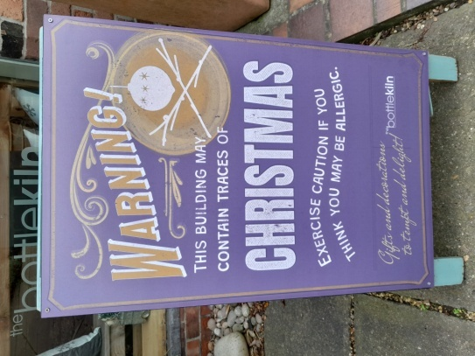

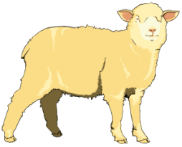

**TADA**

I have a geography joke but I don’t know where it is!

I have a statistics joke but it’s not significant!

I have a Civil Engineering joke but it’s still under construction!

I have an Economics joke but it’s not in demand!

**NEWSLETTER POSTAL CHARGE**

Members who are not on the internet and would like the newsletter posted to them can do this by paying £10 with their annual subscription. This is less than the true cost but it reflects a commitment to receiving it.

**WANTED**

We are looking for volunteer(s) to help to prepare the newsletter each month. If you are interested, please let us know. Training in how to put the elements together provided if necessary.

We are also looking for someone who usually uses Zoom to attend the monthly meetings and who would be willing to act as a Zoom Controller, admitting those who are using the link. Again, training provided if necessary.

**THE TWELVE KNIGHTS OF KING ARTHUR’S**

**OTHER ROUND TABLE**

1/ Sir Cumference - the plumpest knight

2/ Sir Cumspect - the cautious knight

3/ Sir Cumvent - the problem solving knight

4/ Sir Veillance - the observant knight

5/ Sir Charge - the battling knight

6/ Sir Face - the good looking knight

7/ Sir Pass - the competitive knight

8/ Sir Vivor - the resilient knight

9/Sir Render - the timid knight

10/ Sir Loin - the macho knight

11/ Sir Real - the imaginative knight

12/ Sir Plus - the spare knight

*David Willey*

**NOTE FROM THE EDITOR**

Thank you to everyone who has contributed to this month’s newsletter. Please send your contributions for next month to: ***newsletter@eastwoodu3a.org***